☕COFFEE SALES☕

Dataset Overview: Exported coffee dataset where order details, customer details and product details were given for a XYZ coffee organization. Each data contains – Customer ID, Product ID, Region, Country, Size, Price, Names, Roast type names. There are overall 28 customer names

Objective: Created a coffee sales dashboard based on Monthly sales, Highest Buying Customers, Highest coffee sales in which country.

**Data Summary**

***In the first tab*** – **Orders Details**: There are **Order ID, Order Date, Customer ID, Product ID, Quantity** of Orders dataset, converted the data in a Table format. The calculated fields are – **Customer Name, Email Ids, Country, Coffee Type, Roast type, size, Unit Price, Sales, Full Name of Coffee, Roast Type Names, Loyalty Card.**

For Calculated fields [Highlighted in Yellow]: Used excel formulae like- IF Statements,XLOOKUP, INDEX & MATCH function to pull out the desired result.

Xlookup-



Index & Match-



Ifs statement-



Order Date [Highlighted in Blue] : Used custom date function for data sorting & cleaning.

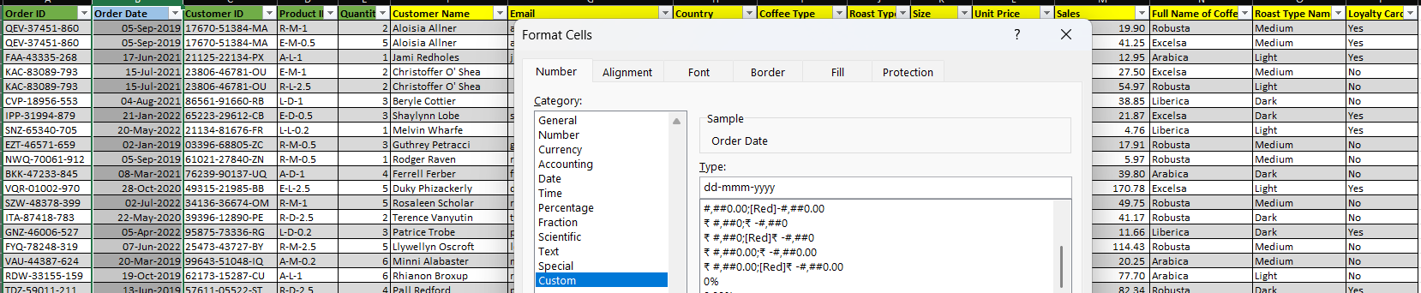

***In the second tab*** –**Customers Details**: There are **Customer ID, Customer Name, Email, Phone Number, Address line1, City, Country, Postcode, Loyalty Card** converted the data in a Table format.

***In the third tab*** – **Product Details**: There are **Product ID, Coffee Type, Roast Type, Size, Unit Price, Price per 100g, Profit** converted the data in a Table Format

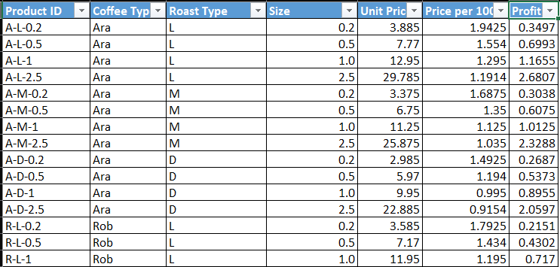

COFFEE SALES DASHBORAD ANALYSIS

The above demonstration is of coffee sales in a dashboard. Where a slicer, Horizontal bar chart, line chart, timeline (in months) is added to show the sale of coffee in a XYZ co. based on monthly basis.

The **slicer** has 3 parts – Based on ROAST TYPE NAME, SIZE, LOYALTY CARD.

The **Timeline** is altered to months as we can see it in the above screenshot (i.e. 2019- November, December; 2020 – January, February) which is linked to the line chart (Total Sales Over Time)

The **Bar Chart** – shows the Top 5 Customers based on the coffee dataset where Loyalty Card is ‘Yes’.

The **Line Chart** – Shows the sale of coffee from the 2019-2020 timeline where different types of coffee names can be seen with different colors – Arabica, Excelsa, Liberica, Robusta.

-------------------------------------------------------------------------------------------------------------------------------------